
International Conference – Dubai 2024
Venue: Mohammed Bin Rashid University of Medicine and Health Sciences
Healthcare City, Date: April 19-22, 2024.
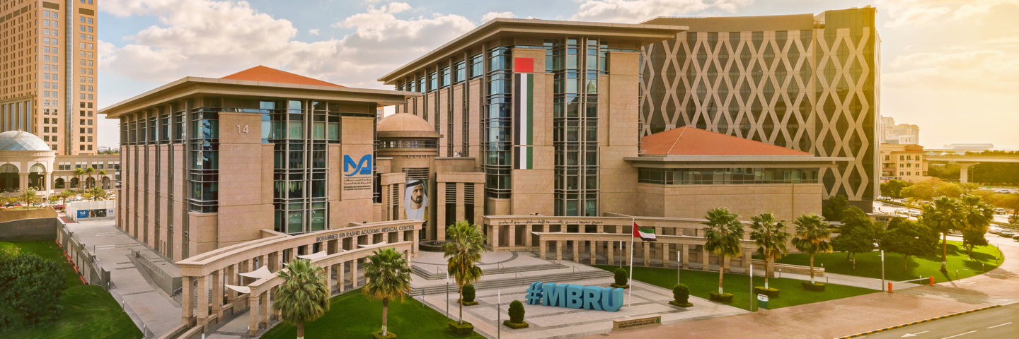

General Information

- Presentation title:

- Information about the Authors:

- Area of the Research Work:

- Profile of the Presenter (1000-character max including spaces)
Abstract Template for the 2023 Photonics Middle East International Conference Dubai (Times New Roman 16, bold, centered)

P. White¹, M. Wang¹, A. G. Brolo^{1,2,*} (Times New Roman 12, normal, centered, underline presenting author)
¹Centre for Advanced Photonics and Related Technologies (Times New Roman 11, centered)
²University of Mars, Department of Bio-Photonics
e-mail: corresponding_author@email.com (Times New Roman 11, normal, centered)

The total length, including figures and all references, is limited to one page. The abstract is to be submitted electronically through the conference website. The submitted abstract should be either a MS Word file (*.doc, *.docx) or a .pdf file.

General recommendations

Format of the abstract
The abstract should be maximum one page and in text only form.
Margins: Top and Bottom: 2.5 cm; Left and Right: 1.5 cm. Gutter: 1 cm.
- Paragraphs: Single line spacing. A single left empty between two consecutive paragraphs.
- Font: Times New Roman. Title: 16 pt, Bold, centered. Authors names: 12 pt, Normal, centered. Affiliations: 11pt, centered. E-mail: 11 pt, Normal, centered. Main text: 12 pt, justified left and right.
- Acknowledgement: Times New Roman, 12 pt, Italic. After the main text and before the references (separated by empty lines).
- Citations: Times New Roman, 12 pt. Cite references using square brackets [1-4]. Examples of the format to be used are given below.

This work was supported by National Grant no. ….

References
[1] A. Author, B. Author, and C. Author, Journal, Volume, Page (Year).
[2] A. Author, Title of Book, Publisher, City (Year).
[3] A. Author and B. Author, Conference, Dates, City, Country, Page (Year).

